**Software Requirements Specification (SRS)**

**Document Title:** AI-Powered Fertilizer Business Web Platform

**Version:** 1.0

**Prepared by:** [Your Team/Company Name]

**Date:** Dec 19th 2024

Table of Contents

1. Introduction 3

1.1 Purpose 3

1.2 Business Problem 3

1.3 Objective 4

1.4 Scope 4

1.5 Definitions, Acronyms, and Abbreviations 4

1.6 References 4

1.7 Overview 5

2. Overall Description 5

2.1 Product Perspective 5

2.2 User Classes and Characteristics 5

2.3 User Interfaces 6

2.4 System Interfaces 6

2.5 Constraints 7

2.6 Assumptions and Dependencies 7

3. Functional Requirements 7

3.1 System Environment 7

3.2 Use Cases 8

3.2.1 Home Page Sub-System 8

3.2.2 Search Bar Sub-system 13

3.2.3 Search Result Sub-system 16

3.2.4 Product Details Sub-system 18

3.2.5 Shopping Cart Sub-system 21

3.2.6 Order Checkout Sub-system 23

3.2.7 Login/Signup Sub-system 26

4. Non-Functional Requirements 28

4.1 Performance 28

4.2 Security 28

4.3 Scalability 28

4.4 Usability 28

4.5 Availability 28

4.6 Compliance 28

5. System Design Constraints 28

6. Glossary 29

7. Appendices 29

7.1 References 29

7.2 Revision History 29

# 1. Introduction

## 1.1 Purpose

The purpose of this Software Requirements Specification (SRS) document is to provide a comprehensive description of the functional and non-functional requirements for the AI-powered fertilizer business web platform. This document will serve as a reference for stakeholders, developers, testers, and project managers to ensure alignment throughout the project lifecycle.

## 1.2 Business Problem

The agriculture industry faces several challenges in adopting modern solutions for procurement, particularly:

1. Limited Accessibility: Many farmers in rural areas lack access to quality agricultural supplies and face logistical difficulties.
2. Low Awareness: There is a lack of awareness among farmers regarding effective farming products and practices, which affects productivity and yield.
3. Manual Shopping Hassles: Traditional shopping methods involve significant time, effort, and resources, which farmers can otherwise use for fieldwork.
4. Market Competition: Local shops dominate the market, and e-commerce platforms need to differentiate by offering superior value and convenience.

Our platform addresses these challenges by introducing an AI-powered, user-friendly online shopping solution that provides:

* Easy access to fertilizers, pesticides, and related agricultural products.
* Intelligent filters and recommendations tailored to farmers' needs.
* Informative content to educate farmers about product benefits and usage.
* Streamlined logistics and payment options, including "Cash on Pickup," to ensure ease of use and reliability.

## 1.3 Objective

The primary objective of our AI-powered Fertilizer and Pesticide E-commerce Platform is to enable farmers to conveniently access fertilizers and pesticides online. The platform leverages artificial intelligence to offer a user-friendly experience, personalized recommendations, and intelligent product discovery. The initiative aims to:

1. **Increase Customer Base:** Attract more farmers and agriculture businesses to adopt online shopping for agricultural supplies.
2. **Enhance Reach and Sales:** Expand the market reach, especially in rural and underserved areas, to boost sales and business growth.
3. **Empower Farmers:** Provide farmers with an efficient and seamless platform to purchase high-quality agricultural products, thereby saving time and effort.
4. **Promote Awareness:** Increase awareness about best practices in agriculture, product usage, and effective farming solutions through AI-driven insights and recommendations.

## 1.4 Scope

The AI-powered fertilizer business web platform is designed to streamline operations, provide personalized fertilizer recommendations using AI, and facilitate e-commerce functionality. The platform will cater to farmers, and internal staff, enabling:

* AI-driven Product browsing and online purchasing.
* AI-driven fertilizer recommendations.
* Real-time order tracking and delivery management.
* Other AI-features (yet to decide) and data Tracking including Customer Behaviour
* Detailed reporting and analytics.

## 1.5 Definitions, Acronyms, and Abbreviations

* **AI**: Artificial Intelligence
* **UI/UX**: User Interface/User Experience
* **API**: Application Programming Interface
* **RTM**: Requirements Traceability Matrix

## 1.6 References

* Agile Methodology Documentation
* Industry Standards for E-Commerce Platforms
* AI And data analytics functionality

## 1.7 Overview

This document includes functional requirements, non-functional requirements, system design constraints, and a glossary. It will be updated as needed during the project lifecycle.

# 2. Overall Description

## 2.1 Product Perspective

The platform will integrate multiple components:

1. **AI Recommendation Engine**: Suggests optimal fertilizers based on soil, crop type, and environmental data.[Next phase]
2. **E-Commerce Module**: Allows users to browse and purchase fertilizers (AI powered)..[Next phase]
3. **Online Delivery and payment**: Allows users to shop online..[Next phase]
4. **Analytics Dashboard**: Provides insights into sales, user behavior, and inventory trends. .[Next phase]
5. **Multi-language support**: Support regional language (e.g., Gujarati) .[Next phase]
6. **Reminders and Advertisements**: Sends WhatsApp messages to remind and advertise purchasing .[Next phase]

## 2.2 User Classes and Characteristics

1. **Farmers (End- users)**:
   * Limited technical expertise.
   * Require simple and intuitive UI.
2. **Business owner**:
   * Moderate technical expertise.
   * Need access to product catalog, customer management, and order management
3. **Technical Staff**:
   * High technical expertise.
   * Need administrative access to manage the platform.

## 2.3 User Interfaces

User interfaces of this web platform can be divided into 3 sections as per below (It only contains functionalities of Phase-1):

1. **User interfaces for End-users (Farmers)**
   1. Home page
   2. Search bar popup page
   3. Search Result page
   4. Product details page
   5. User Accounts & Management page
      1. Login/sign up page
      2. Order History page
      3. Account settings – password, email or address change
   6. Shopping Cart page
   7. Order checkout page
2. **User interfaces for Business owners**
   1. Product Management
      1. Product Listing Page/ Delete feature
      2. Add product page
      3. Edit Product page
      4. Categorize products (crop-based, problem-based, etc.).
   2. Order Management
      1. Order Listing Page
      2. Edit Order (Status, reason, quantity, price etc.)
   3. Customer Management
      1. View customer profiles, order history, and purchase behavior.
      2. Segment customers based on demographics, purchase history, and other criteria.
   4. Content Management
      1. Manage website content (blog posts, articles, FAQs).
   5. Analytics Dashboard
      1. Shows Analysis related to Customers, Orders, Views and Sales

## 2.4 System Interfaces

* **Frontend**: Accessible via modern browsers (Chrome, Firefox, Edge, Safari).
* **Backend**: Hosted on cloud infrastructure - AWS
* **Database**: Relational database (e.g., RDS, Aurora).

## 2.5 Constraints

* Limited budget for development and hosting.
* Target delivery within six months.
* [Yet to be identified and added]

## 2.6 Assumptions and Dependencies

* Availability of Product data and images
* Internet connectivity for end-users.
* Integration with third-party payment gateways.
* [Yet to be identified and added]

# 3. Functional Requirements

## 3.1 System Environment

Use-case diagram of the system as a whole and its description

**Customer-Facing Use Cases**

1. **View Home Page**: Access seasonal offers and navigate the platform.
2. **Search Products**: Discover products using the search bar.
3. **Product Details**: View detailed information about products, including prices and sizes.
4. **Shopping Cart**: Add, update, or remove items and view totals.
5. **Checkout**: Confirm orders with a summary and payment options.
6. **Order History**: Review past purchases and statuses.
7. **Contact Us**: Reach out for support or inquiries.
8. **Login/Signup**: Create or log into accounts for personalized features.

**Business Owner Use Cases**

1. **Manage Products**: Add, edit, or remove product listings.
2. **Manage Orders**: Track and process customer orders.
3. **Customer Management**: Handle customer information and support.
4. **Content Management**: Update banners, descriptions, and educational materials.

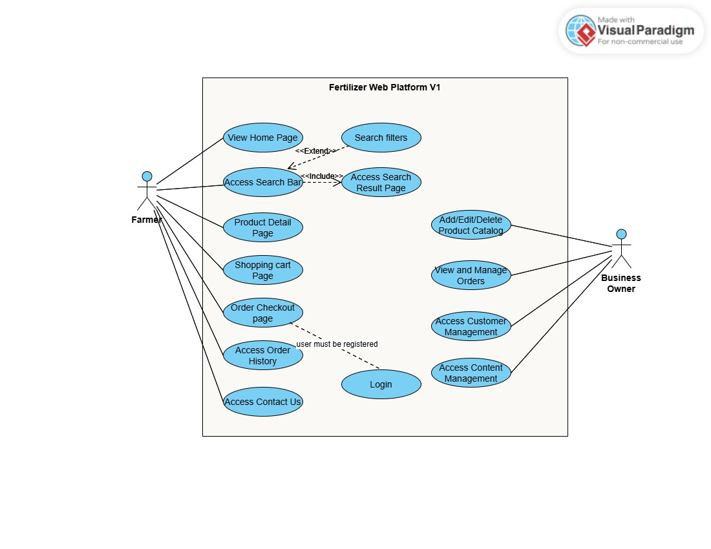

## 3.2 Use Cases

### 3.2.1 Home Page Sub-System

**User Story: Home Page Experience**

* **Title**

As a **farmer or agricultural enthusiast**, I want a well-designed and informative home page so that I can quickly find the products, support, and information I need to enhance my farming experience.

**Description**

The home page acts as the first point of interaction with the platform. It should guide users efficiently to relevant products, offer solutions to common farming problems, and provide easy access to customer support.

**Actors**

1. **Primary Actor:** Farmer or agriculture business owner.
2. **Secondary Actor:** Business Owner (to update seasonal/monthly top products, hero section, and newsletters).

**Preconditions**

1. The user has a device with internet access.
2. The user lands on the home page, either directly or through a search engine.

**Postconditions**

1. The user can easily navigate to relevant product categories or solutions.
2. The user feels encouraged to purchase based on recommendations or social proof.
3. The user can subscribe to the newsletter or contact support if needed.

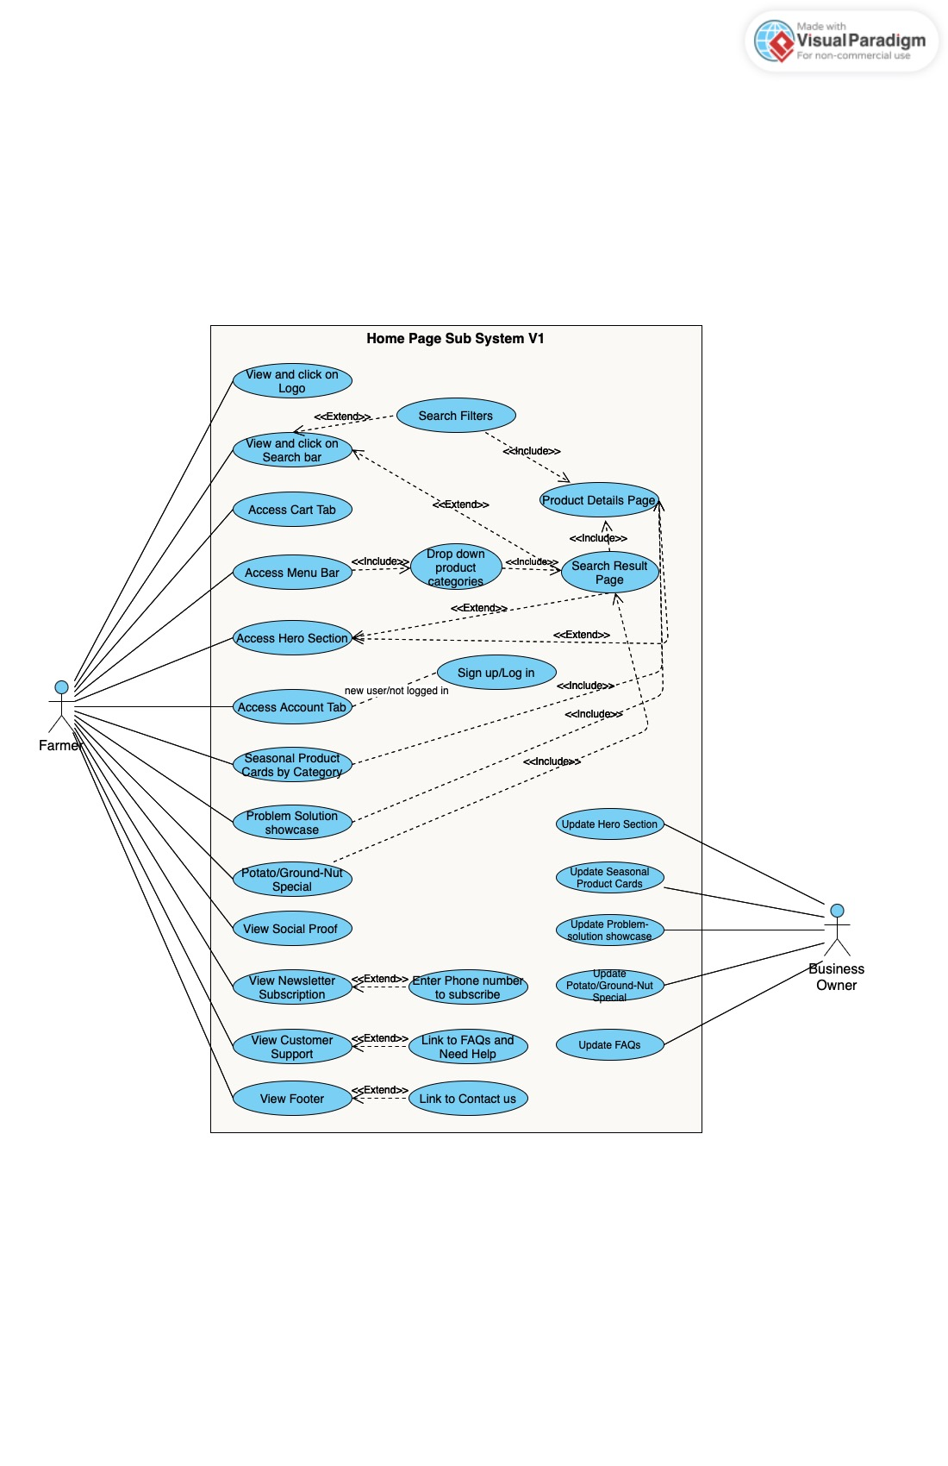

**Acceptance Criteria**

**Logo, Search, Account, and Cart Section**

**Scenario 1: Clicking the Logo Redirects to Home Page**

**Given**: The user is on any page of the platform.  
**When**: The user clicks on the logo.  
**Then**: The system redirects the user to the home page.

**Scenario 2: Using the Search Bar**

**Given**: The search bar is visible on the platform.  
**When**: The user types a product name, category, or keyword and presses Enter.  
**Then**: The system redirects the user to the Search Results page.

**Scenario 3: Accessing the Account Section**

**Given**: The user is logged in or on the platform.  
**When**: The user clicks the account button.  
**Then**: The system displays options to log in, sign up, or manage the user’s profile.

**Scenario 4: Viewing the Cart**

**Given**: The cart icon is visible on the platform.  
**When**: The user clicks the cart button.  
**Then**: The system redirects the user to the shopping cart page and displays the number of items in the cart.

**Hero Section**

**Scenario 5: Displaying a Seasonal Banner**

**Given**: The user is on the home page.  
**When**: The system loads the page.  
**Then**: The hero section displays a banner highlighting seasonal offers or products.

**Scenario 6: Interacting with the Call-to-Action Button**

**Given**: A call-to-action button (e.g., "Shop Now") is visible in the hero section.  
**When**: The user clicks on the button.  
**Then**: The system redirects the user to the appropriate page (e.g., product details or Search Results).

**Seasonal/Monthly Top Products**

**Scenario 7: Viewing Seasonal or Monthly Products**

**Given**: The user is on the home page.  
**When**: The Seasonal/Monthly Top Products section loads.  
**Then**: The system displays 4-6 product cards categorized under Weed Control, Disease Prevention, and Deficiency Prevention.

**Scenario 8: Redirecting to Product Details**

**Given**: The user is viewing the Seasonal/Monthly Top Products section.  
**When**: The user clicks on a product card.  
**Then**: The system redirects the user to the product details page.

**Problem-Solution Showcase**

**Scenario 9: Highlighting Farming Problems and Solutions**

**Given**: The user is on the home page.  
**When**: The Problem-Solution Showcase section loads.  
**Then**: The system displays common farming problems with corresponding solutions and links to relevant filtered search results.

**Potato and Ground-nut Special Section**

**Scenario 10: Showcasing Best-Selling Products**

**Given**: The user is on the home page.  
**When**: The Potato and Ground-nut Special section loads.  
**Then**: The system displays best-selling products for these crops with details and a "Buy Now" button.

**Scenario 11: Redirecting to Product Purchase Page**

**Given**: The user is viewing the Potato and Ground-nut Special section.  
**When**: The user clicks on the "Buy Now" button for a product.  
**Then**: The system redirects the user to the product details or search results page

**Social Proof Section**

**Social Proof Section**

**Scenario 12: Displaying Real-Time Purchase Updates**

**Given**: The user is on the home page.  
**When**: The Social Proof section loads.  
**Then**: The system displays real-time updates like "Ram from Jaipur just bought Organic Fertilizer – 5 kg!"

**Newsletter Subscription Section**

**Scenario 13: Prompting for Newsletter Subscription**

**Given**: The user is on the home page.  
**When**: The Newsletter Subscription section loads.  
**Then**: The system displays a message prompting the user to sign up for farming tips and offers.

**Scenario 14: Subscribing to the Newsletter**

**Given**: The user is in the Newsletter Subscription section.  
**When**: The user enters their phone number and submits.  
**Then**: The system confirms the subscription with a thank-you message and sends promotions via WhatsApp.

**Customer Support Section**

**Scenario 15: Accessing Customer Support**

**Given**: The user is on the home page.  
**When**: The user clicks on the customer support widget or link.  
**Then**: The system displays options to chat or redirects the user to the FAQ/help center.

**Footer Section**

**Scenario 16: Viewing Policies and Contact Information**

**Given**: The user is on any page of the platform.  
**When**: The footer section loads.  
**Then**: The system displays links to policies (e.g., Privacy Policy, Terms & Conditions) and contact details (e.g., phone number, email, address).

### 3.2.2 Search Bar Sub-system

**User Story: Search Bar Functionality**

**Title**

As a **farmer or agricultural enthusiast**, I want to use a versatile search bar so that I can quickly find products or filter them by fertilizers or pesticides with additional options to refine my search.

**Description**

The search bar is an integral feature that allows users to find products using text input or quick category buttons for Fertilizers and Pesticides. It provides relevant filters based on the chosen category (e.g., brands for fertilizers, pest types for pesticides) and displays results dynamically, enhancing the user's search experience.

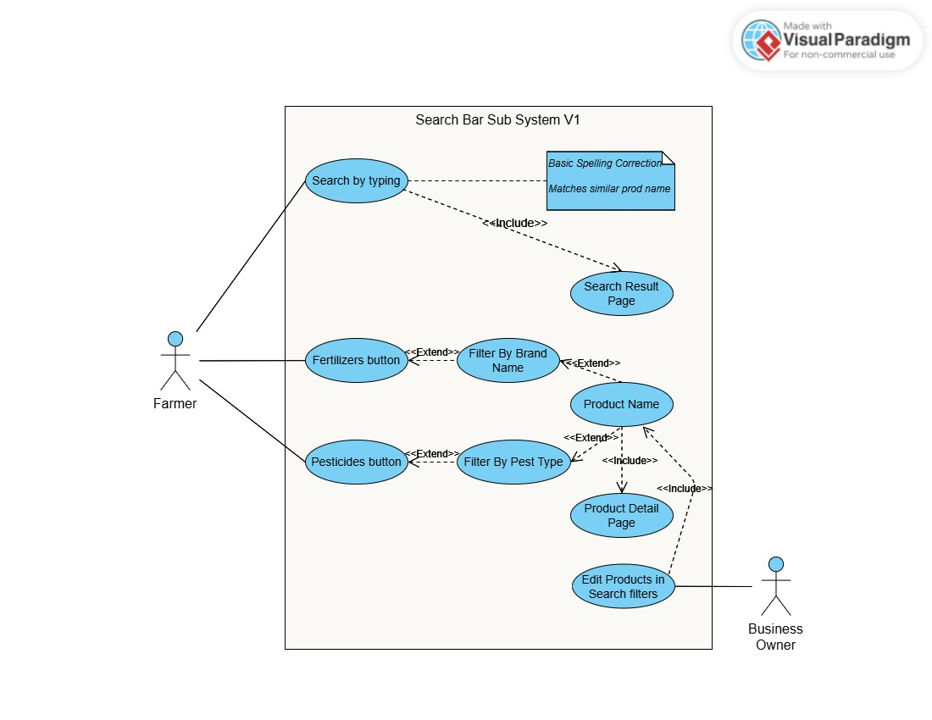

**Actors**

* 1. **Primary Actor:** Farmer or agriculture business owner.
  2. **Secondary Actor:** Business Owner (to manage product list under filters).

**Preconditions**

1. The user has accessed the home page or a page containing the search bar.
2. The product database has been indexed and is available for search queries.

**Postconditions**

1. The user is redirected to a search results page with relevant products based on the query.
2. The user can view and click on filtered lists of products directly on the same page by selecting predefined filters (e.g., Brand Name or Pest Type) and being redirected to the product details page of the clicked product.

**Acceptance Criteria**

**Search Functionality**

**Scenario 1: Using the Search Bar**

**Given**: The user is on the platform and the search bar is visible.  
**When**: The user types product names, categories, or keywords into the search bar and presses Enter.  
**Then**: The system redirects the user to a search results page displaying relevant products sorted by relevance or popularity.

**Fertilizer Button**

**Scenario 2: Viewing Filters for Fertilizers**

**Given**: The user is on the Search Bar pop page and clicks the Fertilizer button.  
**When**: The system loads filter buttons for fertilizers based on Brand Name.  
**Then**: The product list updates dynamically to highlight only fertilizers from the given brands in filter buttons

**Scenario 3: Selecting a Fertilizer Brand Filter**

**Given**: The Fertilizer button is active, and brand name filters are displayed.  
**When**: The user selects a specific brand from the filter options.  
**Then**: The system updates the product list on the same popup page to highlight only fertilizers from the selected brand.

**Pesticides Button**

**Scenario 4: Viewing Filters for Pesticides**

**Given**: The user is on the Search Bar pop page and clicks the Pesticides button.  
**When**: The system loads filters for pesticides based on Pest Type (e.g., Herbicides, Insecticides).  
**Then**: The product list updates dynamically to highlight only pesticides from the given pest type buttons.

**Scenario 5: Selecting a Pest Type Filter**

**Given**: The Pesticides button is active, and pest type filters are displayed.  
**When**: The user selects a specific pest type from the filter options.  
**Then**: The system updates the product list on the same popup page to highlight only pesticides targeting the selected pest type.

**Product List**

**Scenario 7: Navigating to the Product Details Page**

**Given**: The product list is displayed on the Search bar popup page.  
**When**: The user clicks on a product name or thumbnail.  
**Then**: The system redirects the user to the product details page for the selected product.

**Dynamic Updates**

* Filters dynamically highlight results without requiring a page refresh.
* The user can reset or modify their filters without losing their current selections.

### 3.2.3 Search Result Sub-system

**Title**

Search Results Page

**Description**

The Search Results page allows users to refine their product search by applying various filters, sorting options, and exploring relevant results. Users can also access the menu, search bar, account, and cart tabs, and navigate to product details directly from the page.

**Actors**

* **User**: A customer looking for fertilizer and pesticide products.
* **System**: The web platform that displays the filtered search results dynamically.

**Preconditions**

1. The user has performed a search query or selected a category from the menu bar.
2. Products related to the query or category are available in the database.

**Postconditions**

1. The system displays a list of products filtered and sorted based on the user’s inputs.
2. The user can navigate to a product detail page for more information.
3. All filters can be cleared to return to the unfiltered product list.

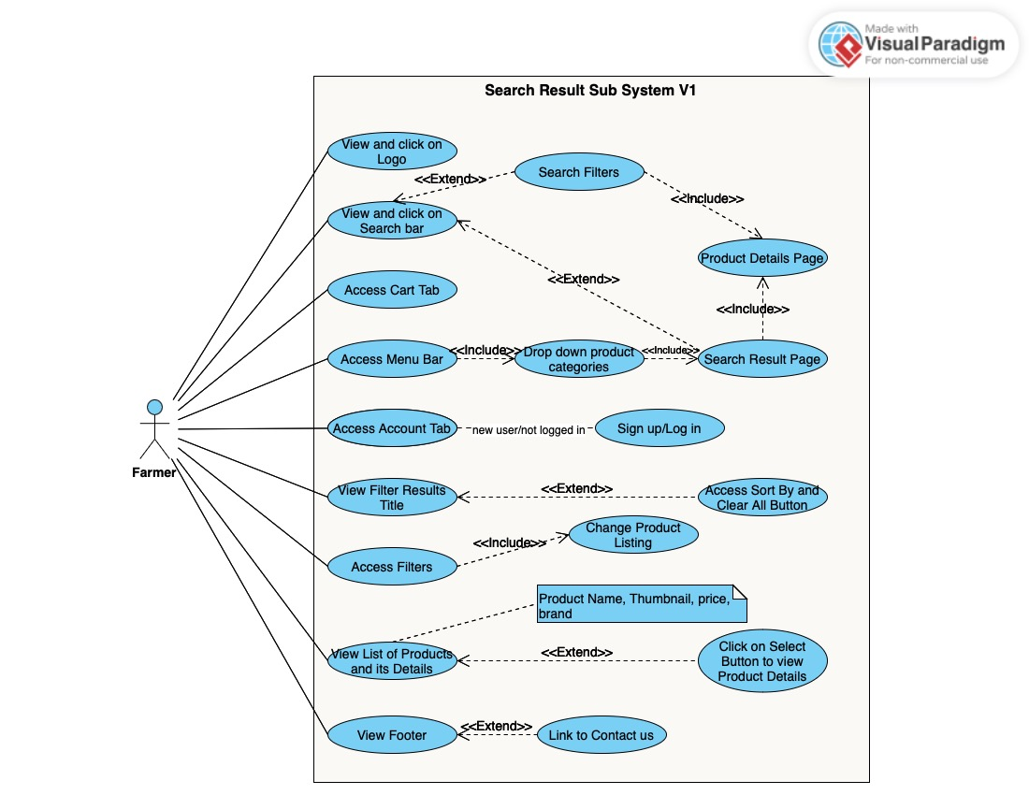

**Acceptance Criteria**

**Scenario 1: View Search Results**

**Given**: The user has entered a search query or selected a category.  
**When**: The page loads.  
**Then**: The system displays relevant products along with filters, sorting options, and navigation links.

**Scenario 2: Apply Filters**

**Given**: The user wants to narrow down the product list.  
**When**: They select filters like price range, size, brand, or product form.  
**Then**: The system dynamically updates the product list to match the selected filters.

**Scenario 3: Clear All Filters**

**Given**: The user has applied multiple filters.  
**When**: The user clicks the "Clear All" button.  
**Then**: All filters are removed, and the product list resets to its original state.

**Scenario 4: Sort Products**

**Given**: The user wants to organize the displayed products.  
**When**: They choose a sorting option (e.g., Price: Low to High).  
**Then**: The system rearranges the product list based on the selected sorting criterion.

**Scenario 5: View Product Details**

**Given**: A list of products is displayed.  
**When**: The user clicks on a product thumbnail or name.  
**Then**: The system navigates the user to the product detail page.

### 3.2.4 Product Details Sub-system

**Title**

Search Results Page

**Description**

As a user, I want to view and interact with the product details page to access product information, select options, and add items to the cart for purchase.  
**Actor**: Farmer

**Precondition** The user is on the product details page, and all product-related information is loaded.  
**Postcondition**: The user can view the product, interact with filters and options, and successfully add the item to the cart.

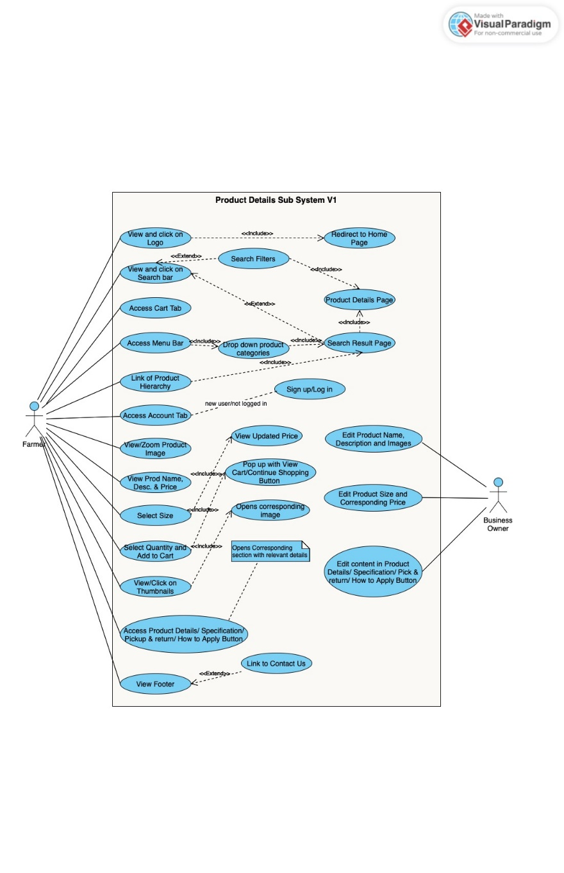

**Acceptance Criteria**

**Logo, Search, Account, and Cart Section**

* **Scenario 1: Navigate to Home Page via Logo**  
  **Given**: The product details page is loaded.  
  **When**: The user clicks the logo.  
  **Then**: The system redirects the user to the home page.
* **Scenario 2: Search for Products**  
  **Given**: The search bar is visible.  
  **When**: The user types a query and submits it.  
  **Then**: The system redirects to the search results page with relevant results.
* **Scenario 3: Access signup/login page**  
  **Given**: The account button is visible.  
  **When**: The user clicks it.  
  **Then**: The system redirects to the login/signup page.
* **Scenario 4: Access Cart Page**  
  **Given**: The cart button is visible.  
  **When**: The user clicks it.  
  **Then**: The system redirects to the cart page.

**Product Image Interaction**

* **Scenario 5: Zoom Product Image**  
  **Given**: The product image is displayed.  
  **When**: The user hovers over the image.  
  **Then**: The system zooms in on the product image for better visibility.
* **Scenario 6: Update Main Image from Thumbnails**  
  **Given**: Thumbnails are displayed below the main image.  
  **When**: The user clicks a thumbnail.  
  **Then**: The main product image updates to display the selected thumbnail.

**Product Information and Pricing**

* **Scenario 7: Display Product Details**  
  **Given**: The product name, description, and price are displayed.  
  **When**: The user views the product details.  
  **Then**: The system ensures all details are accurate and visible.
* **Scenario 8: Update Price by Size Selection**  
  **Given**: Size selection buttons are displayed.  
  **When**: The user selects a size.  
  **Then**: The system dynamically updates the price based on the selected size.

**Adding Product to Cart**

* **Scenario 9: Add Product to Cart**  
  **Given**: The quantity selector and "Add to Cart" button are visible.  
  **When**: The user selects a quantity and clicks "Add to Cart."  
  **Then**: The system adds the selected quantity to the cart and updates the cart count.

**Additional Product Information Sections**

* **Scenario 10: Display Additional Information**  
  **Given**: Buttons for Product Details, Specifications, Pickup & Return, and How to Apply are visible.  
  **When**: The user clicks one of these buttons.  
  **Then**: The system displays the corresponding content dynamically without refreshing the page.

**Footer Section**

* **Scenario 11: Access Footer Links**  
  **Given**: The footer section is displayed.  
  **When**: The user clicks a footer link (e.g., Privacy Policy, Terms & Conditions, or Contact Us).  
  **Then**: The system redirects the user to the respective page or displays the relevant information.

### 3.2.5 Shopping Cart Sub-system

**Title**

Shopping Cart Page

**Description**: As a user, I want to view the products in my shopping cart, modify quantities, and proceed to the checkout page to finalize my order.

**Actor**: Farmer  
**Precondition**: The user has added at least one product to the shopping cart, and the shopping cart page is loaded.  
**Postcondition**: The user can view the cart contents, modify quantities, and proceed to the checkout page successfully.

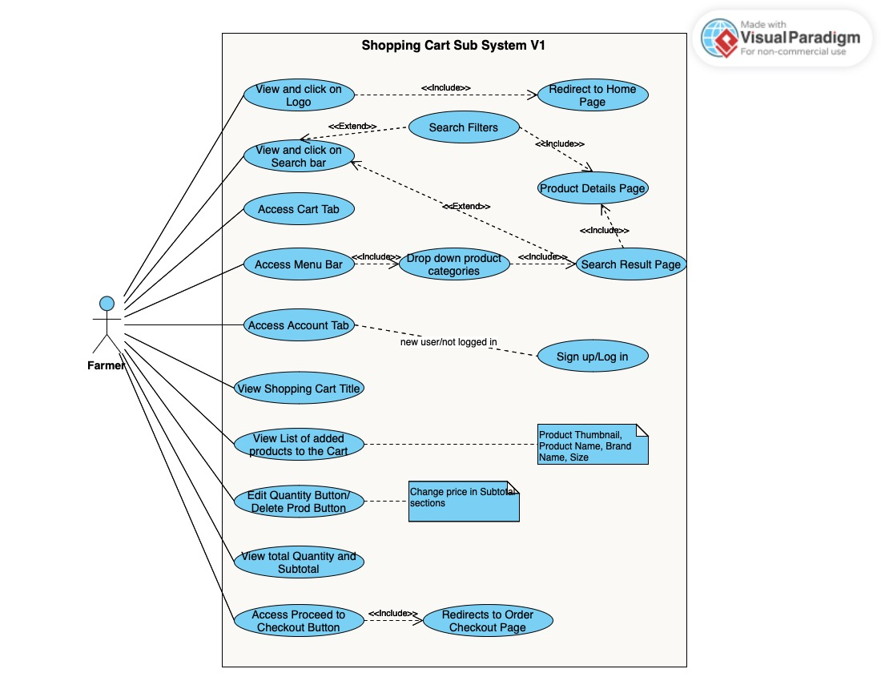

**Acceptance Criteria**

**Logo, Search, Account, and Cart Section**

* **Scenario 1: Navigate to Home Page via Logo**  
  **Given**: The product details page is loaded.  
  **When**: The user clicks the logo.  
  **Then**: The system redirects the user to the home page.
* **Scenario 2: Search for Products**  
  **Given**: The search bar is visible.  
  **When**: The user types a query and submits it.  
  **Then**: The system redirects to the search results page with relevant results.
* **Scenario 3: Access signup/login page**  
  **Given**: The account button is visible.  
  **When**: The user clicks it.  
  **Then**: The system redirects to the login/signup page.
* **Scenario 4: Access Cart Page**  
  **Given**: The cart button is visible.  
  **When**: The user clicks it.  
  **Then**: The system redirects to the cart page.

**Viewing and Modifying Cart Contents**

* **Scenario 5: View Cart Products  
  Given:** The shopping cart contains products.  
  **When:** The user views the shopping cart page. **Then:** The system displays the product thumbnails, names, brands, sizes, and quantities for all items in the cart.
* **Scenario 6: Update Quantity of Products  
  Given:** A product in the cart has a quantity control button (increase/decrease). **When:** The user clicks the increase or decrease button.  
  **Then:** The system updates the product quantity and recalculates the subtotal dynamically.
* **Scenario 7: View Subtotal  
  Given:** The shopping cart contains products.  
  **When:** The user views the subtotal section. **Then:** The system displays the updated subtotal reflecting all products and their quantities.

**Proceed to Checkout**

* **Scenario 8: Proceed to Checkout  
  Given:** The "Proceed to Checkout" button is visible.  
  **When:** The user clicks the button. **Then:** The system redirects the user to the order checkout page.

**Footer Section**

* **Scenario 9: Access Footer Links  
  Given:** The footer section is displayed. **When:** The user clicks a footer link (e.g., Privacy Policy, Terms & Conditions, or Contact Us).  
  **Then:** The system redirects the user to the respective page or displays the relevant information.

### 3.2.6 Order Checkout Sub-system

**Title:**

Order Checkout Page for Fertilizer E-commerce Platform

**Description:**

The order checkout page allows users to finalize their purchase by reviewing their order details, modifying product quantities or sizes, and confirming the order. It includes a summary of products, subtotal, final total, payment method, and options for post-purchase actions.

**Actors:**

Primary User: Customer  
Secondary User: System

**Preconditions:**

* The user has logged into their account or user can pay as a guest.
* The user has added products to the cart and initiated the checkout process.
* Products, prices, and quantities have been selected previously.

**Postconditions:**

* The order is successfully placed, and the user is shown a confirmation message.
* The system updates the order database and makes the order visible on the "Orders" page.
* The cart is cleared for the next shopping session.

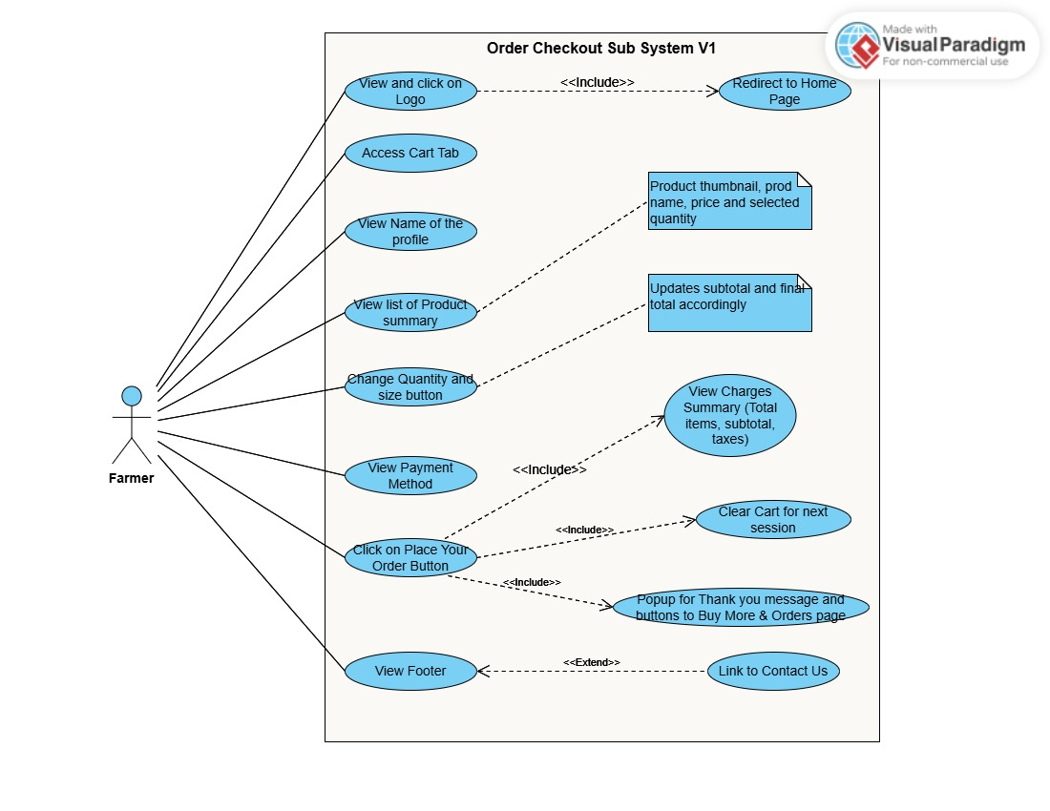**Acceptance Criteria**

**Scenario 1: Display User Information**

**Given:** The user lands on the checkout page.  
**When:** The page loads.  
**Then:** The name of the logged-in user is displayed at the top of the page. If not logged-in, display the name as a “Guest”

**Scenario 2: View Product Summary**

**Given:** The user has products in the cart.  
**When:** The checkout page is displayed.  
**Then:** The product list shows the thumbnail, name, selected size, quantity, price, subtotal, and final total.

**Scenario 3: Modify Product Quantity**

**Given:** The user wants to change the quantity of a product.  
**When:** The user updates the quantity using the +/- buttons.  
**Then:** The subtotal and final total are dynamically updated without a page refresh.

**Scenario 4: Modify Product Size**

**Given:** The user wants to change the size of a product.  
**When:** The user selects a different size using the size dropdown or buttons.  
**Then:** The subtotal and final total are dynamically updated without a page refresh.

**Scenario 5: Select Payment Method**

**Given:** The user is reviewing payment options.  
**When:** The page displays the payment section.  
**Then:** The user sees "Cash on Pickup" as the only available payment method.

**Scenario 6: Place Order and View Confirmation**

**Given:** The user has reviewed their order details.  
**When:** The user clicks the "Place Your Order" button.  
**Then:**

1. A confirmation pop-up appears with a "Thank you" message.
2. Two buttons are displayed: "Shop More" and "View Orders."

**Scenario 7: Redirect to the Orders Page**

**Given:** The user clicks the "View Orders" button in the confirmation pop-up.  
**When:** The button is clicked.  
**Then:** The user is redirected to the "Orders" page displaying their recently placed order.

**Scenario 8: Continue Shopping**

**Given:** The user clicks the "Shop More" button in the confirmation pop-up.  
**When:** The button is clicked.  
**Then:** The user is redirected to the home page to continue shopping.

**Scenario 9: Footer Visibility**

**Given:** The user is on the checkout page.  
**When:** The page is displayed.  
**Then:** The footer section is visible and identical to the home page, showing contact information, policies, and links.

### 3.2.7 Login/Signup Sub-system

**Title:**

As a user, I want to be able to log in or sign up on the website, and recover my password if forgotten, so that I can securely access my account and perform desired actions.

**Acceptance Criteria:**

1. **Login Functionality:**
   * **Given:** I have a registered account,  
     **When:** I enter my correct username/phone number and password,  
     **Then:** I should be logged in successfully and redirected to the homepage or dashboard.
   * **Given** I have a registered account,  
     **When** I enter an incorrect username/phone number or password,  
     **Then** I should see an error message indicating an invalid username/phone number or password.
2. **Signup Functionality:**
   * **Given** I do not have an existing account,  
     **When** I enter a valid phone no and password and click on "Sign Up,"  
     **Then** I should be registered and logged into the system, and redirected to the homepage or dashboard.
   * **Given** I do not have an existing account,  
     **When** I enter a phone no that is already in use and try to sign up,  
     **Then** I should see an error message stating that the email is already in use.
3. **Forgot Password Link:**
   * **Given** I am on the login page,  
     **When** I click on the "Forgot Password?" link,  
     **Then** I should be redirected to a password recovery page where I can enter my registered phone no.
   * **Given** I have entered my registered phone no on the password recovery page,  
     **When** I click on "Submit,"  
     **Then** I should receive an SMS on phone no with a password reset link if the phone no is valid.
   * **Given** I have entered an unregistered phone no on the password recovery page,  
     **When** I click on "Submit,"  
     **Then** I should see an error message indicating "phone no not found."
4. **Password Reset:**
   * **Given** I have received the password reset link in SMS,  
     **When** I click on the reset link,  
     **Then** I should be redirected to a page where I can enter a new password.
   * **Given** I am on the password reset page,  
     **When** I enter a new password that meets the password requirements (e.g., minimum length, character types),  
     **Then** I should be able to submit the new password.
   * **Given** I have successfully reset my password,  
     **When** I submit the new password,  
     **Then** I should be redirected to the login page to log in with my new password.

### 3.2.8 Admin Dashboard Sub-system

**Description**

The Admin Dashboard is designed for the business owner to manage the e-commerce platform's products, orders, customer profiles, and promotional content. This sub-system provides tools to streamline platform operations, enhance product visibility, and maintain customer engagement.

**Actors**

Business Owner (Admin)

**Preconditions**

* The business owner must be logged into the admin account with appropriate privileges.
* The database must be operational and connected for real-time updates.

**Postconditions**

* Changes made by the business owner (e.g., product updates, order edits) are saved and reflected on the customer-facing platform.
* Analytics or logs are updated for tracking administrative actions.

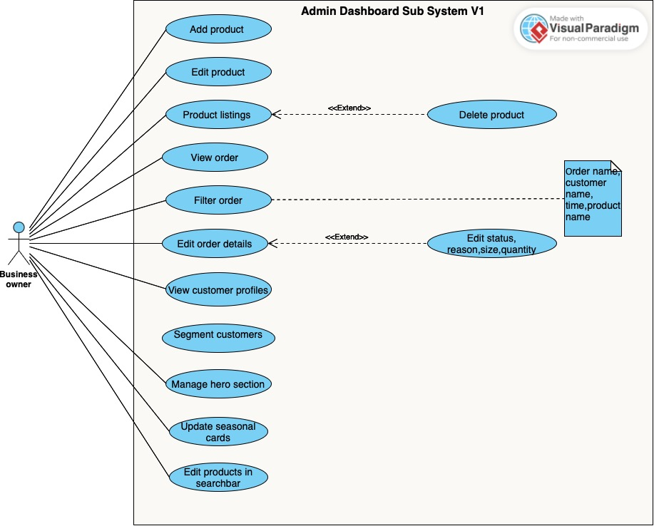

**Acceptance Criteria**

**Scenario 1: View Product Listing**

**Given:** the business owner is logged into the admin dashboard,  
**When:** they navigate to the product listing page,  
**Then:** they should see a table displaying all products with details like name, price, and Brand, along with a delete option for each product.

**Scenario 2: Delete Product**

**Given:** the business owner is on the product listing page,  
**When:** they click on the delete option for a product,  
**Then:** the product should be removed from the listing, and the change should reflect on the customer-facing platform.

**Scenario 3: Add New Product**

**Given:** the business owner is on the add product page,  
**When:** they fill in the required fields (e.g., name, price, category) and submit the form,  
**Then:** the new product should be added to the product list and appear on the customer-facing platform.

**Scenario 4: View and Filter Orders**

**Given:** the business owner is on the orders page.  
**When:** they apply filters like time, product name, or customer name.  
**Then:** the displayed orders should be updated to match the filter criteria.

**Scenario 5: Edit Order Details**

**Given:** the business owner is viewing an order,  
**When:** they edit details like order status, reason, product size, or quantity,  
**Then:** the updated information should be saved and reflected in the customer’s order history.

**Scenario 6: View Customer Profiles**

**Given:** the business owner is on the customer management page,  
**When:** they select a customer profile,  
**Then:** they should see detailed information about the customer and their purchase history, along with segmentation options.

**Scenario 7: Manage Hero Section Images**

**Given:** the business owner is on the dashboard,  
**When:** they add or update images in the hero section,  
**Then:** the new images should appear on the homepage banner.

**Scenario 8: Update Seasonal Cards**

**Given:** the business owner is on the dashboard,  
**When:** they add new products or update existing ones in seasonal cards,  
**Then:** the changes should reflect under the corresponding section on the homepage.

**Scenario 9: Edit products in Search Bar Filters**

**Given:** the business owner is on the dashboard,  
**When** they edit products for filters associated with the search bar,  
**Then** the search functionality should reflect the updated products under the corresponding filters.

# 4. Non-Functional Requirements

## 4.1 Performance

* The system should handle **50 concurrent users** without performance degradation.
* Page load time: < 3 seconds.

## 4.2 Security

* User data must be encrypted in transit (TLS) and at rest (AES-256).
* Secure login with **Phone Number** and password reset functionality

## 4.3 Scalability

* The platform should scale to support **900 active users**.
* Backend services should use horizontal scaling.

## 4.4 Usability

* Intuitive UI with minimal learning curve.
* Multi-language support for at least three regional languages.

## 4.5 Availability

* System uptime: 99.9%.
* Recovery time after a failure: < 30 minutes.

## 4.6 Compliance

* Adherence to GDPR, PCI DSS for payment processing.

# 5. System Design Constraints

* Frontend must use a responsive design framework (e.g., React, Angular).
* Backend APIs should follow RESTful principles.
* Database should support ACID compliance.

# 6. Glossary

* **Fertilizer Recommendation**: Suggestions for fertilizers based on user-provided data.
* **Order Tracking**: System to monitor the status of purchases.
* **Crop disease classification**: AI-powered image classification and Recommend related product

# 7. Appendices

## 7.1 References

* [Links to third-party APIs and libraries].
* [Industry standards for AI recommendation systems].

## 7.2 Revision History

|  |  |  |
| --- | --- | --- |
| **Version Date** | **Changes** | **Author** |
| Jan-07-2025 | Initial Draft | Abhi Patel |
|  |  |  |

|  |  |  |  |
| --- | --- | --- | --- |
|  |  |  |  |

**End of Document**